**Delete the Documents into Collections**

**db.COLLECTION_NAME.delete Many(DELLETION_CRITTERIA):**

Delete the document in db.

**Excercises:**

1. **Delete student who have class CS.** 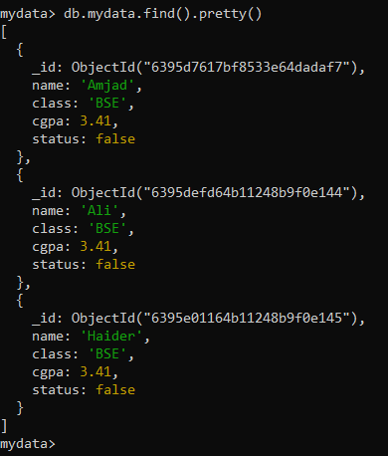
2. **Delete all documents in collection.** 